LCD Display
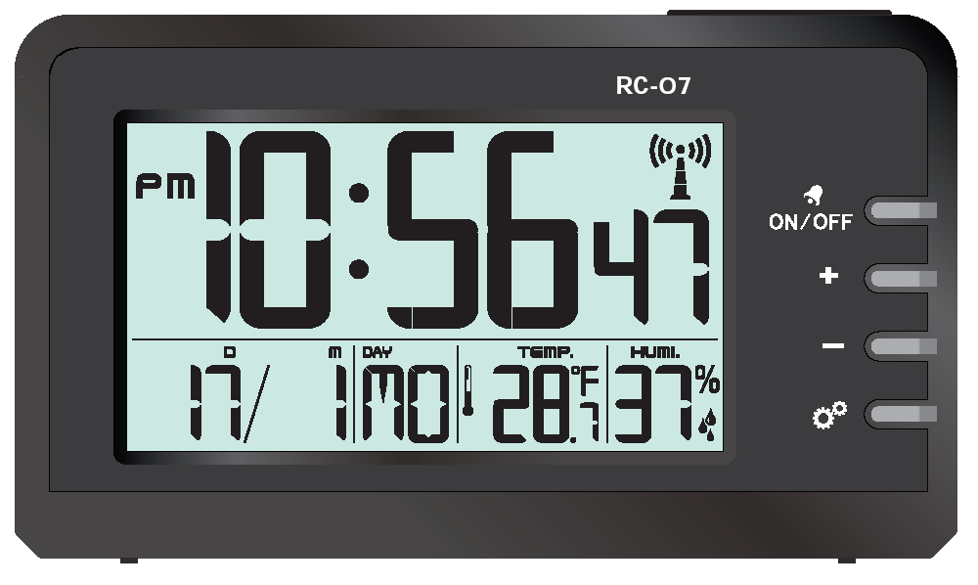
- Main functions：
  - Five function keys : 【SET/RCC】、【UP/12-24】、【DOWN/CF】、【ALM ON/OFF】、【SN/LIGHT】
【RESET】 button near the back battery box
  - seconds , minutes, hours, date ,week, month ;
  - toggle alarm time and month-day display
  - Indoor Ambient Temperature: -10.0℃～50℃ [14℉～122℉]
  - Environment Humidity:19%-99%
  - Automatic Clock Reception (DCF/MSF/WWVB).
  - Alarm and snooze function, 5 minutes delay alarm
  - LED backlight, delay 10 seconds
- Power & Reset
  - On Power or Reset, LCD full display 3 seconds, at the same time backlight lit 3 seconds → buzzer make a “BI”sound , → select the national area →Normal state→ check temperature and humidity → Enter the RCC signal reception .
[Power On this product requires the user to first select Set Country region: DCF= European EU; MSF = English UK; WWVB= United States US, or go to setup mode to select Country area, when no signal is received in the area, automatically loops in three zones . signal will base on the last time you received ]
[Select the interface in the national area, press [SN/LIGHT] button to switch selection, confirm by press any other key, if not, then the default is DCF European EU].

 | Display time | Month / Day | Date | Week default language | Temperature  unit | RCC | Jet Lag | Alarm Time
DCF= EU | 00:00:00 (24hr) | D/M | 2018 -1-1, | German | ℃ | ON | 0 | 7:00am
MSF= UK | 12:00am (12hr) | D/M | 2018 -1-1, | English | ℃ | ON | 0 | 7:00am
WWVB = US | 12:00am (12hr) | M/D | 2018 -1-1, | English | ℉ | ON, DST ON | E | 7:00am
  - Power on default perpetual calendar display:
- operation and display:
  - Key functions : 【SET/RCC】、【UP/12-24】、【DOWN/CF】、【ALM ON/OFF】、【SN/LIGHT】
 |  | 【SET/RCC】 | 【ALM ON/OFF】 | 【UP/12-24】 | 【DOWN/CF】 | 【SN/LIGHT】
Standard mode | Single Press | Start / exit receive RCC | Turn on and display the alarm clock / display Month Day | 12/24 Hour Switch | Temperature unit ℃/℉ switch | Light LED 10 seconds
 | Long Press | Enter Time setting | Enter Alarm setting | ------ | ------ | ------
Clock setting | Single Press | confirm settings | ------ | Single Step increase | Single Step Descending | Light LED 10 seconds
 | Long Press | ------ | ------ | 8 Steps / second increase | 8 Steps / second decrement | ------
Alarm setting | Single Press | ------ | confirm settings | Single Step increase | Single Step Descending | Light LED 10 seconds
 | Long Press | ------ | ------ | 8 Steps / second increase | 8 Steps / second decrement | ------

  - Key operation:
- Single press【SET/RCC】key ( no key tone ), start RCC receive, and then press exit RCC receive
- Long Press 【SET/RCC】key, buzzer BI sound , enter time setting
- Single press【ALM ON/OFF】key, buzzer BI sound , Turn on the alarm and switch to the alarm clock time display; Press this key again( no key tone ) turn off the alarm and switch to month-day display
- Single press【SN/LIGHT】key , backlight lighting ten seconds
- When the alarm clock is ringing, press any key to stop the noise, press 【SN/LIGHT】 button , Enter the snooze state, will delay 5 minutes Alarm
  - Time setting:
- Long Press【SET/RCC】key, buzzer BI sound, enter time setting
- the Setting order is:
Setting Order | CY | ZONE
DCF = EU | Country → | Time zone → | Years → | DM/MD → | Month → | Day → | Language → | 12/24h → | Hours → | Min → | Exit
MSF = UK | Country → | Time zone → | Years → | DM/MD → | Month → | Day → | Language → | 12/24h → | Hours → | Minutes → | Exit
WWVB = US | Country → | Time zone → | Years → | DM/MD → | Month → | Day → | Language → | 12/24h → | Hours → | Minutes → | DST On/off → | Exit
- set range for year to 2000~ 2099 , the week changes with the day of the year, and the seconds to zero when you set the Minutes
- when set, the item being set will blink with the 1HZ frequency
- Press the【SET/RCC】key to determine the setting result and move to the next setup item
- Press【UP/12-24】button , Set the item forward one step, and hold down 2 seconds to advance at the 8 steps per second
- Press【DOWN/CF】button, set the item back one step, and hold down 2 seconds to rewind at the 8 steps per second
- no setting in 20 seconds will save settings and exit
- Partial Details:
- In USA ,WWVB has DST settings selection, DST setting to ON, successfully receiving WWVB signal, display DST ICON, US time plus 1 hours, DST set to Off , successfully receive WWVB signal, do not display ICON for DST , don’t add 1 hour.
- EU DCF version and UK version of MSF , if a DST signal is received, ICON showing DST
- Time zone offset, European DCF version and UK version of MSF , time setting mode has +-12 hour adjustment, adjust rear time display offset
- time zone description :
DCF version EU Time Zone: | +-12H
MSF version UK Time Zone: | +-12H
WWVB U.S. version US time zone [ has 7 ] :
 | Atlantic–at (GMT-4)
 | Eastern–e (GMT-5)
 | Central–c (GMT-6)
 | Mountain–m (GMT-7)
 | Pacific–p (GMT-8)
 | Alaskan–ak (GMT-9)
 | Hawaii –h (GMT-10)

- Language corresponds to five languages:
Language | Hereinafter | Monday | Tuesday | Wednesday | Thursday | Friday | Saturday | Sunday
English | EN | MO | TU | WE | TH | FR | SA | SU
French | FR | LU | MA | ME | JE | VE | SA | DI
German | GE | MO | DI | MI | Do | FR | SA | So
Italian | IT | LU | MA | ME | GI | VE | SA | Do
Spanish | SP | LU | MA | MI | JU | VI | SA | Do

  - Alarm Settings:
- standard mode, single press 【ALM ON/OFF】 key open the alarm clock, display the alarm time,
- Alarm Clock display mode, and then press 【ALM ON/OFF】Close Alarm Clock , show month and date
- Long Press【ALM ON/OFF】Key entry Alarm Clock Setup mode
- set in order: Hours minutes Exit
- when setting, the item being set will blink with the 1HZ frequency
- Press 【ALM ON/OFF】The key determine the setting result and goes to the next setup item
- Single Press 【UP/12-24】 key, Set the item forward one step, and long press this key ,to rewind at the 8 steps per second

- Single Press 【DOWN/CF】 key, set the item back one step, long press this key does not put, will be at 8 steps per second speed back
- The alarm setting is completed , the setting clock open and display .
- no settings within 20 seconds will save settings and exit

- Functions and effects description
  - RCC function .
- Enter RCC receive condition:
  - power on or reset into RCC receive
  - Press the【SET/RCC】key to force access to RCC receive
  - When receiving , press the【SET/RCC】key to stop RCC receive
  - When receiving , only 【SN/LIGHT】 key can work, to operate other keys, you need to exit RCC receive status
  - RCC receive ,a travel clock version description, the RCC signal is received according to the country area set by the user, will be in DCF→MSF→ WWVB switch sequentially between the three. For example: The last time you received a successful WWVB format, the next time you turn on RCC reception takes precedence over WWVB 's RCC radio format
- RCC received 4-10 minutes
- RCC Receive graphics:
- signs flashing When receiving
b) when receive successful, the RCC receive symbol will be full displayed ;
c)When the signal is received unsuccessfully the symbol disappeared and exit the RCC.
- any not set mode, press "SET/RCC" key, enter RCC manual Receive mode , no functions press any other keys during receive process,, and single press "SET/RCC" Key to stop RCC receive
- on a daily basis 1:03,2:03,3:03 Force receive; 4:03,5:03 Select Receive if 1:03 ,2:03,3:03 received successfully, 4:03 and 5:03 are no longer automatically received, the maximum time of each receive is 10 minutes, If the correct time is not received within the specified time, the receive is automatically stopped.
  - Alarm function:
- Alarm Time 2 minutes
- Alarm format:0-20 seconds, per second bi bi 2 sounds,21-60 seconds, per second bi bi bi-bi 4 sounds ,61-120 seconds, continuous BI sounds
- When the alarm is ringing, press 【SN/LIGHT】 key to delay the alarm 5 minutes, press the other key to exit the alarm
  - Temperature and humidity features:
- Temperature detection range: -10.0℃～50℃[14℉～122℉] , higher than 50℃ display HH. H, less than -10℃ will display LL.L
- Humidity Range: 19% ~ 99% , higher than 99% show HH, below 19% will show LL, temperature display HH. H or LL. L , Humidity display --
- temperature and humidity detection period : 30 Seconds
- Temperature error Range: 20℃～30℃，±1.5℃; other interval ±2℃
- Humidity error Range:30%-80%, ±4%; other interval ±6%
- pause temperature and humidity detection when Alarm noisy or when receiving RCC.
- Work Parameters
Project | Unit | MIN | TYPE | MAX
Operating voltage | V | 2.4 | 3.0 | 3.5
Static current | UA | -- | -- | 30
Operating temperature | ℃ | -10 | -- | 50

